NEA ANALYSIS
Blackheath and Bromley are a sports club with a wide range of facilities. Blackheath and Bromley attract people of all ages, abilities and areas since they have a rich history of high level athletes ranging from world champions and Olympic gold medallists. Some of the notable athletes are Dina Asher-Smith and Adam Gemili.
The club is aware that the current way of confirming and managing memberships are outdated and difficult to maintain. Members have been finding it hard to keep on track with how much they are paying and what they are actually paying for in the first place. Some of the problems that is a cause of this is the changing of track prices every few months in accordance with the building of new facilities. Such as the sauna and the ice baths pushing up the price of all the memberships once again.
The club would like a system that allow members and staff to have a overview on the different parts of the club that they are interested in such as the gym, sauna, yoga classes, track etc.
The new system will require staff and members to register to create a profile. This will then be stored on a computer system, the data within the computer system will be stored on a database. Which will make searching and sorting the gathered data easy. The data can also be securely held and backed up regularly so that there is no chances of it being lost.
A system should also be made that links each profile created by a member of the club to their relevant interests.
The people who would benefit from this new system would be the whole club (Members, staff etc) from all range of ages. A online system would make sign ups to the club as a whole quicker, the storage of member details will be more secure and centralised, online payments will make payments more trackable. Along with being able to track your own attendance and performance within the club.
This online system will help staff especially since the new online system would save time, reduce the amount of paperwork to little or none and make the club be more organised and potentially more professional than it already is.
PURE GYM
- The Off – Peak membership is the most affordable option however it is only useful for people who are available within the limited access hours. Therefore although it is the cheapest membership option, for most people it will not a suitable option due to other commitments.
- The Core membership is the most suitable plan for people who are regular gym goers but also if the person has commitments such as work, school etc. The core membership will be suitable since the hours are not limited meaning they can go at any time within the day to fit it into their own routine.
- The Plus membership is the most expensive plan however comes with the most benefits to try justify the price which they are selling the membership at. Such as multi-gym access, Freezing membership, flavoured water with vitamins and off the 60% off gym brands. These benefits aren’t really essential meaning this is not a go to membership to get.
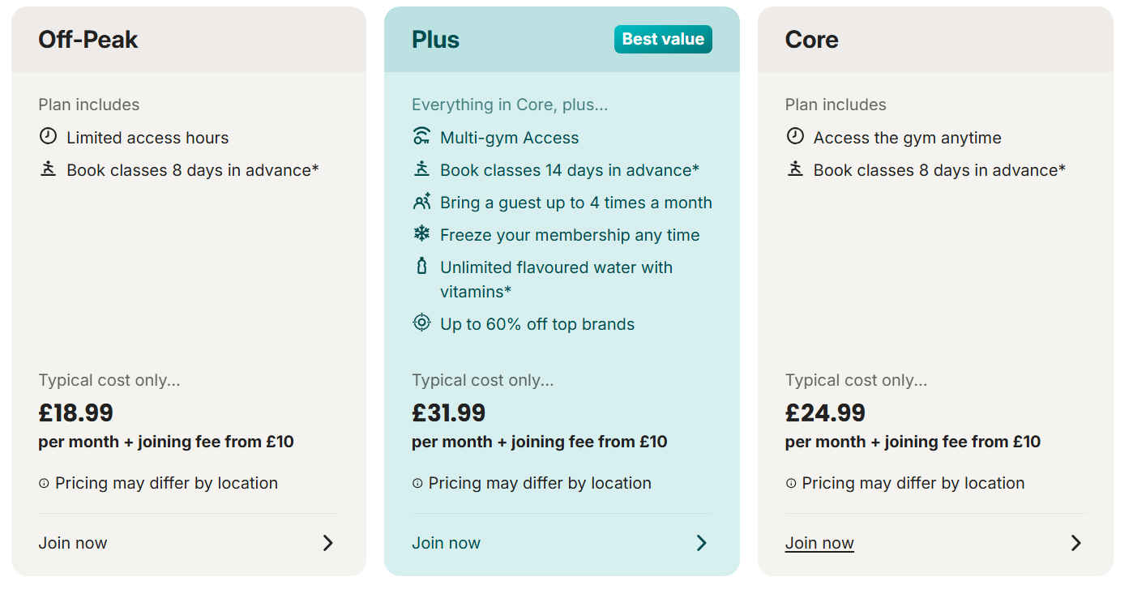

However PureGym regularly do discounts on all of their membership prices such as 50% off for 3 months. This would encourage more people to come to PureGym and pick up a membership since they would of only paid half the price while they have started and if they find that they are enjoying PureGym they can continue their membership or if not they can cancel their membership with the knowledge that they only paid half the price for it in the first place.
THE GYM GROUP
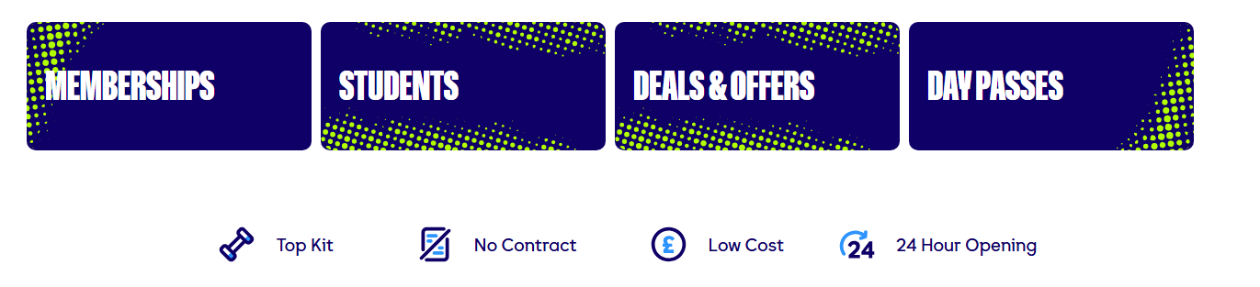
Within the gym group membership page it contains, Saver Monthly or Student.
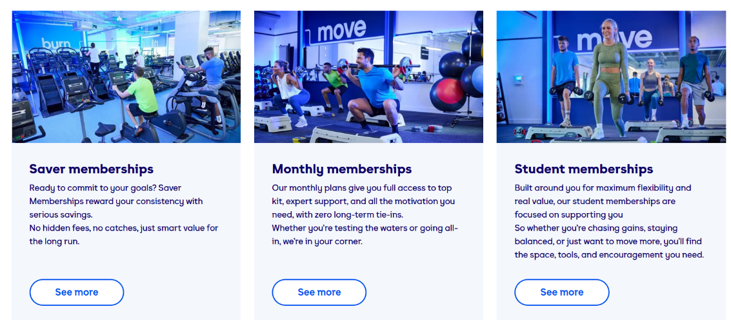 Saver would be directed towards a person who is looking to go to the gym but not for a high price but they still get a good amount of value out of the money they have paid for the membership. Within saver they have a slightly more expensive saver membership giving them a wide range of benefits for the higher expense in which they need to pay. However the ultimate saver membership is actually more or less the same as the Ultimate monthly membership, the use of psychological pricing gives off the effect that if you buy the Ultimate saver membership you are going to get more membership benefits along with a lower price than if you got the Ultimate monthly. Meaning more people would buy the Ultimate saver with the intention that they will give more for less.

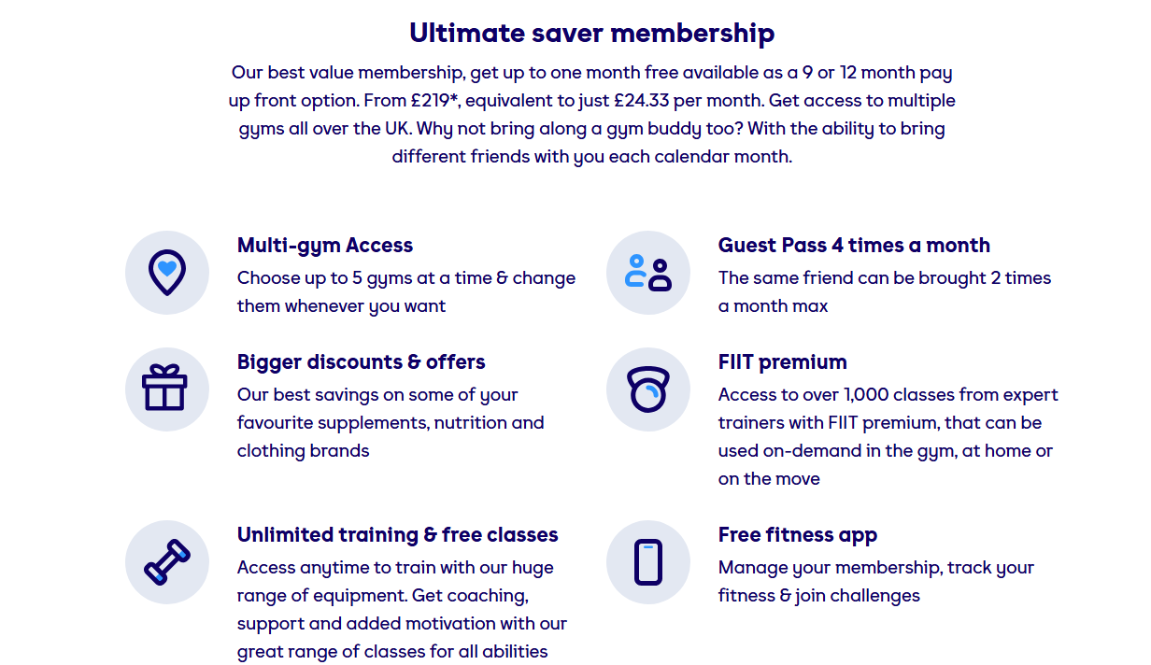
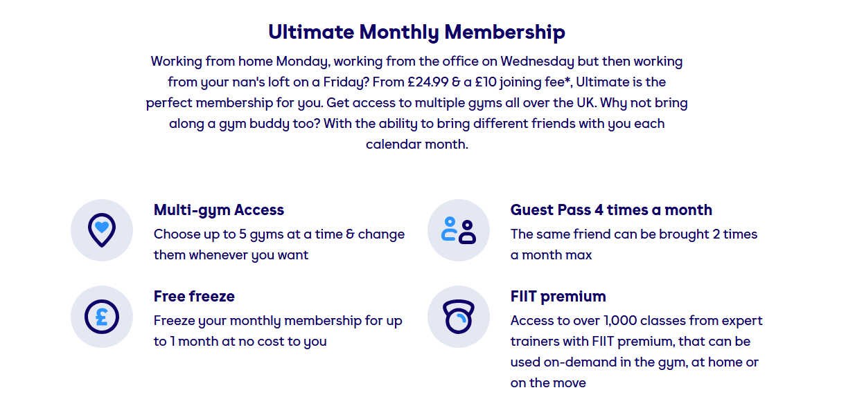

INTERVIEWS
Staff:
- Staff complained that using the clipboard was a challenge and they had no other system in place to track members.
- Staff complained that the amount of members in the club was high meaning they had to use multiple clipboards
- Staff agreed that an online system would be beneficial for the club.
- Staff discussed that not all parents and children might understand how the new system would work.
- Staff suggested that a guide would need to be put in place for new users
Members:
- Members said that a online system would help them keep up with any updates to the membership prices since they happen a lot.
- Members agreed the wait time to pay for the track was long and it being a quicker process could save them a lot of time overall.
- Members said that when referring their friends to the club the overall membership pricing was confusing since they had loads of different services they had to pay for.
- Members agreed having a guide of how the upcoming online system worked would be beneficial and help stop any confusion that may happen.
Limitations of my design
- If my design isn’t secure member details could be at risk
- Some members or parents may still find it harder to use than that of the current system
- If a person’s internet is down they would be unable to access the online platform limiting access to all features
- Bugs or login problems could stop members from the club using the platform all together leading to internal issues

The Gym Group Login Page
The gym group use a easy to understand and basic Login Page, which helps to keep confusion limited since users only need their own email address and the gym pin they were given when they first signed up. Furthermore, if they don’t remember their pin. A pin retrieval page where you put in your unique information and a link will be sent by email to you. Where you will be able to see your pin and save it if necessary. 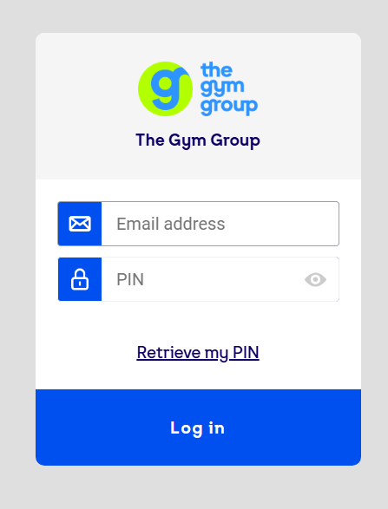

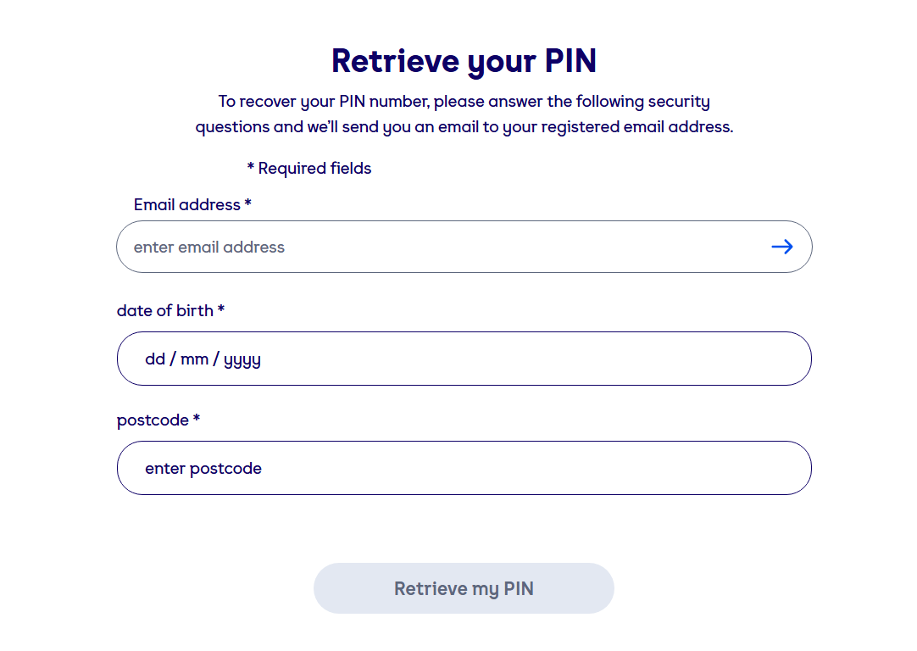

Pure Gym Settings Menu
Pure gym has a very insightful settings menu which gives you information on nearly everything you could need. The different Memberships , Classes and even how to do certain exercises if your new. As someone who would be just starting out, a basic easy to use menu would help the member feel more confident and comfortable while starting their fitness journey.

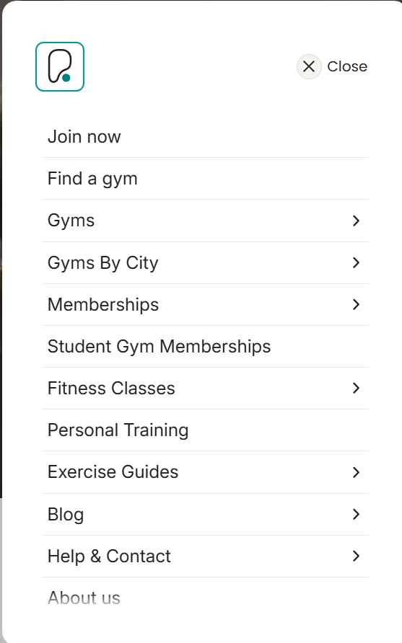
IMPROVEMENTS
- There are too many different membership options which could cause confusion by someone who is looking for the perfect membership for them. I am going to consolidate all of these membership options into just three. Student, Pay as you go and Monthly you will be able to see the clear differences in benefits which will eventually justify the price at which each membership is at.
- I will make a website where you are able to freeze your membership, which means not locking it behind a higher paywall which is a more expensive membership. All memberships regardless of it being the cheapest or the most expensive should be able to control if their membership is active or inactive.
- The student membership will be affordable since students have somewhat a lot to pay for especially if they are in university and if they don’t have a job they may struggle to afford it meaning the cheaper the more engagement the clubhouse would get from wide ranges of people.

User privileges
- ✓ Be able to log in / log out
- ✓ View their own details (Membership Status, Password)
- ✓ Make Payments
- ✓ Renew Membership
- ✓ Book Classes
- ✓ Cancel Classes
- ✗ Add/Remove other members
- ✗ Change other members info

- Staff privileges
- ✓ Be able to log in / log out
- ✓ View their own details
- ✓ Terminate / Manage User Memberships
- ✓ Mange Classes
- ✓ Manage Members In Each Class
- ✓ Add/Remove Users
- ✗ Add/Remove other staff
- ✗ Change other staff info

OBJECTIVES
- Create a secure login system for members and staff so they can only access data relevant to their role
- Allow members to register and update their personal details with all changes then saved to the database
- Store all membership data in a database which can be easily searched through by staff by membership ID or name
- Create a payment tracking system for the different membership which tracks if a member has paid or has an outstanding payment pending
- Allow authorised staff to view every members attendance through the system
- Send emails or display updates/news about events and training with authorised staff being able to add, edit and remove any
- Make a clear system interface so that users are able to access all features within a few clicks
- Make sure all accounts are protected by a password and make sure unauthorised users aren’t able to access staff functions.

Frontend:
User Interface:
- Login Screen
- Dashboard for members
- Dashboard for the staff
- Payment Screen
- Booking page for slots that are hour based
- Settings Menu
Frontend Features:
- Clear layout
- Easy navigation through the use of buttons and drop down menus
- Conformation Messages (“Payment has gone through”)
- Validation Messages (“ Settings have been updated”)
Backend:
- Use OOP to create classes for the members, staff, payment etc.
- I will use OOP since it helps to keep the program maintained and organised
- Use SQL to store information such as membership status/types, login info, member details etc
- Use a hashing algorithm to slow down brute force attacks
- Hash passwords before storing them anywhere
- Validate user inputs to reduce invalid data and prevent SQL injections
- Require logging in before access security protected pages
- Check login details against saved details in database
- Generate reports for staff

